Report provides the overview of Data protection policies and countries with highest GDP, Life expectancy and the combination of GDP of countries which have highest life expectancy through various data tables and pictorial representations.

**Rekha Poloju**

Assignment 1 Data Visualization

01/Oct/2023

Contents

1. Part 2 (the PDF document) 2

1.1 First Task 2

1.1.1 Policies and Procedures 2

1.1.2 Why it is important to be aware of the data rules as a data analyst? 2

1.2. Second Task Excel 3

1.2.1 Set password to protect the workbook 3

1.2.2 Change data in column C to display the data in British Pound symbol 3

1.2.3 Turn GDP data into a table and apply filter to show only 2019 data 4

1.2.4 Create chart showing Country, Per Capita and Rank 5

1.2.5 Sort for the top 20 highest ranking countries 5

1.2.6 Create a bar chart for top 20 countries 6

1.2.7 Colour the area underneath the table 6

2. Part 3 (the PDF document) 7

2.1 Create 3 macro buttons 7

2.2 Paste the data in to a new word document (Gross domestic product) 7

2.3. Add a header and footer to the table 8

3. Part 4 (the PDF document) 9

3.1 Import data and set the relation 9

3.2 Create charts 9

3.3 Dashboard 11

4. Reflective 12

4.1 What went well 12

4.2 Areas of Development 12

4.3 Lessons learnt 12

# 1. Part 2 (the PDF document)

## 1.1 First Task

### 1.1.1 Policies and Procedures

Keeping organisation’s data and information secure has never been more important. Businesses not only face the threat of cybersecurity breaches, but also the ramifications of data privacy and protection legislation. It is essential to handle data and information properly to keep it organised and secured. To achieve this, data protection goes beyond the system you use to store files, and into the practices and behaviour across the organisations.

Every country across the world has different levels of privacy laws. Some, including Europe and America, have very robust policies that protect the personal information of the individual, whilst other countries, such as Africa and certain parts of South America have very limited data protection laws. Therefore, it is vitally important not to assume that all countries have the same laws as those you are used to.

As an example, the UK GDPR sets out seven key principles for data protection;

* Lawfulness, fairness and transparency.
* Purpose limitation.
* Data minimisation.
* Accuracy.
* Storage limitation.
* Integrity and confidentiality (security)
* Accountability.
* Data Breach Notification Procedures

### 1.1.2 Why it is important to be aware of the data rules as a data analyst?

As a data analyst, it is crucial to understand the importance of data protection and the steps that must be taken to ensure that sensitive information is kept secure. Data protection refers to the measures put in place to prevent unauthorized access, use, alteration, disclosure, or destruction of personal information. This includes both paper and electronic records.

## 1.2. Second Task Excel

### 1.2.1 Set password to protect the workbook

* Click on File of the excel that need to be password protected
* Then click on info option on the left-hand side on the toolbar
* On the righthand side of the page you see the option ‘Protect Workbook’
* Click on the protect workbook and add a password
* once Password added close the sheet and reopen to confirm if the password protection is applied and password is working

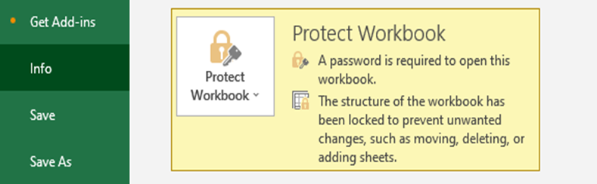

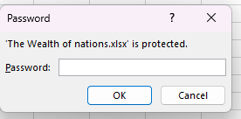

### 1.2.2 Change data in column C to display the data in British Pound symbol

* Select column ‘C’
* Click on Data type/formatting option on the tool bar
* Select the data type as ‘Currency’ and currency type ‘£’ from the drop down

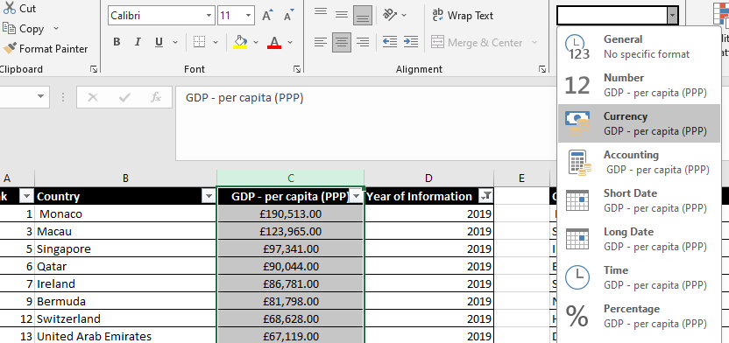

### 1.2.3 Turn GDP data into a table and apply filter to show only 2019 data

* Select all data by pressing Ctrl+A together and then press ctrl+T to create a table. In the pop-up window provide the table name of your choice.
* Once table is created use drop down in column to select value 2019 only to show the data related the year 2019

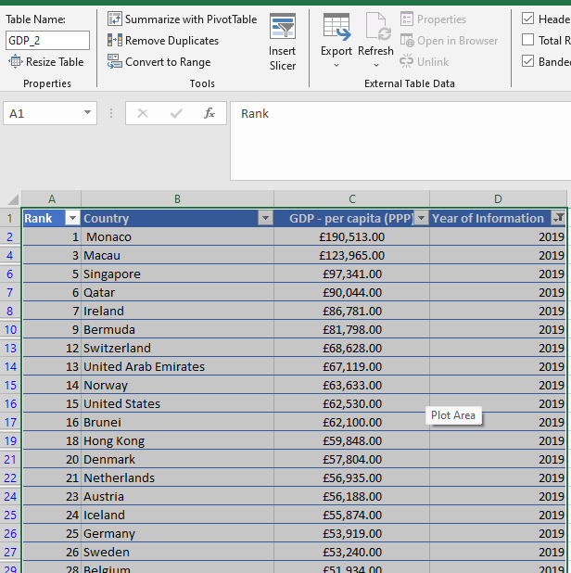

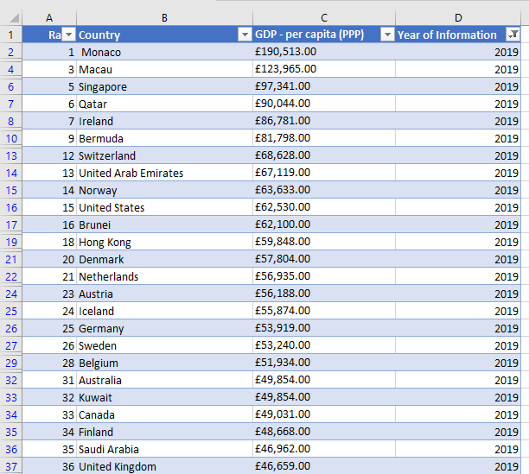

### 1.2.4 Create chart showing Country, Per Capita and Rank

* Select columns Country, Per capita and Rank and then click on insert tab on the tool bar
* Click on chart and then choose the bar chart

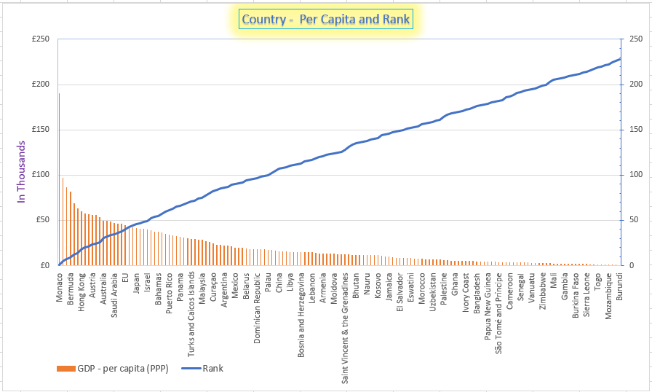

### 1.2.5 Sort for the top 20 highest ranking countries

* Select the rank column and click on Sort option in the tool bar
* Select the option ascending
* Next choose the option expand the

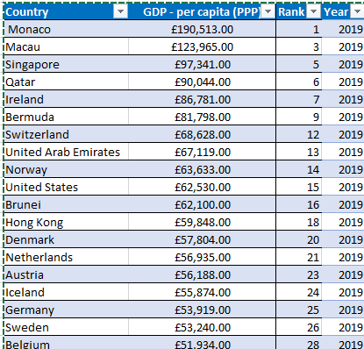

### 1.2.6 Create a bar chart for top 20 countries

* Select columns Country, Per capita and Rank and then click on insert tab on the tool bar
* Click on chart and then choose the bar chart

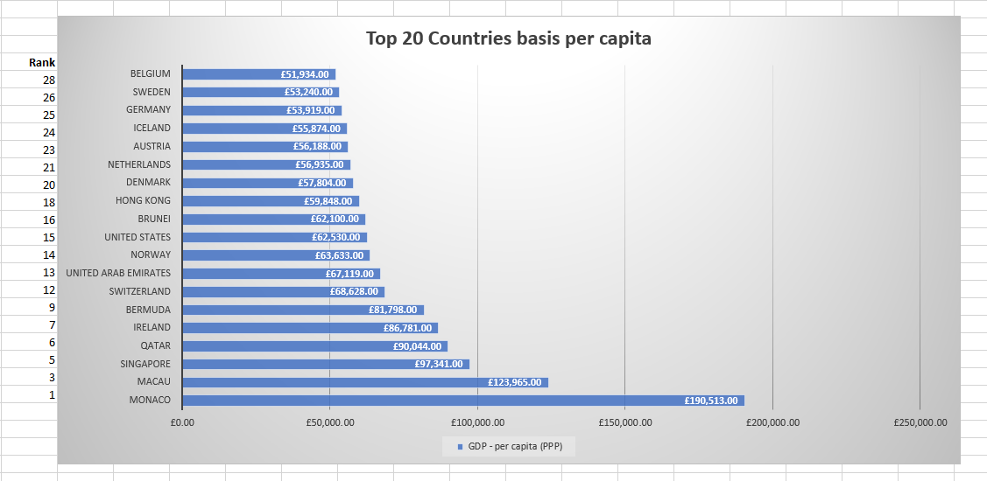

### 1.2.7 Colour the area underneath the table

* Highlight the area to be coloured
* Fill the colour of your choice

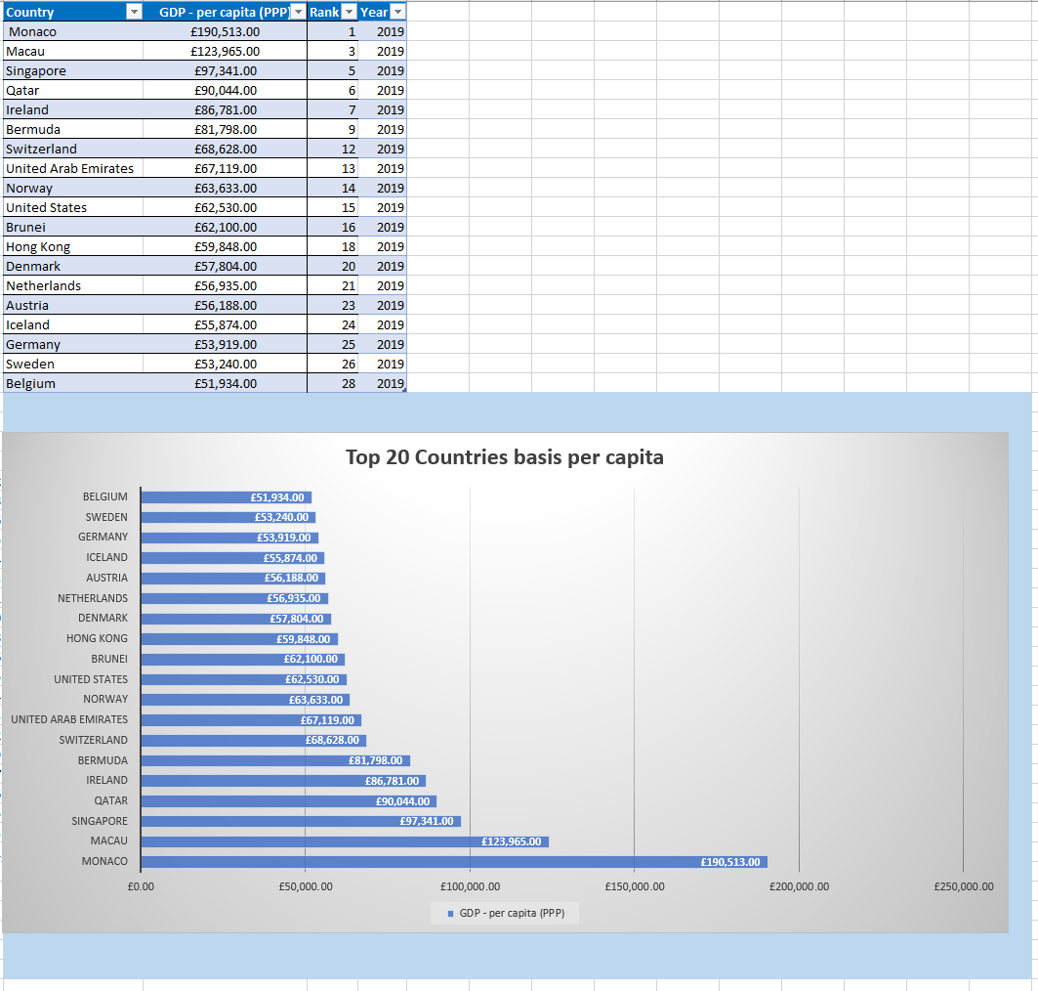

# 2. Part 3 (the PDF document)

## 2.1 Create 3 macro buttons

* Select the data to be copied
* Click on View option on the tool bar
* Click on the drop-down arrow on the Macros
* Select record macro
* Name the macro
* Then either Copy command from the tool bar or press CTRL+C
* Go back to macro and select stop recording
* To create a button, go to developer tab on the tool bar
* Click on insert then select a shape
* Change the title of the button by double clicking on the shape
* Once done click outside the shape and then right click on the shape to assign the macro
* From the existing list of macros select the macro that was recorded in the above step

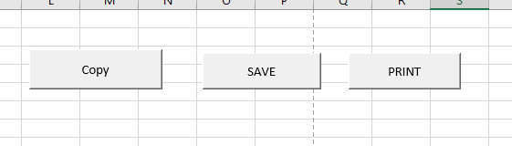

## 2.2 Paste the data in to a new word document (Gross domestic product)

* Once data has been copied using the macro press CTRL+V to paste the data in the word document

|  |  |  |  |
| --- | --- | --- | --- |
| **Country** | **GDP - per capita (PPP)** | **Rank** | **Year** |
| Monaco | £190,513.00 | 1 | 2019 |
| Macau | £123,965.00 | 3 | 2019 |
| Singapore | £97,341.00 | 5 | 2019 |
| Qatar | £90,044.00 | 6 | 2019 |
| Ireland | £86,781.00 | 7 | 2019 |
| Bermuda | £81,798.00 | 9 | 2019 |
| Switzerland | £68,628.00 | 12 | 2019 |
| United Arab Emirates | £67,119.00 | 13 | 2019 |
| Norway | £63,633.00 | 14 | 2019 |
| United States | £62,530.00 | 15 | 2019 |
| Brunei | £62,100.00 | 16 | 2019 |
| Hong Kong | £59,848.00 | 18 | 2019 |
| Denmark | £57,804.00 | 20 | 2019 |
| Netherlands | £56,935.00 | 21 | 2019 |
| Austria | £56,188.00 | 23 | 2019 |
| Iceland | £55,874.00 | 24 | 2019 |
| Germany | £53,919.00 | 25 | 2019 |
| Sweden | £53,240.00 | 26 | 2019 |
| Belgium | £51,934.00 | 28 | 2019 |

## 2.3. Add a header and footer to the table

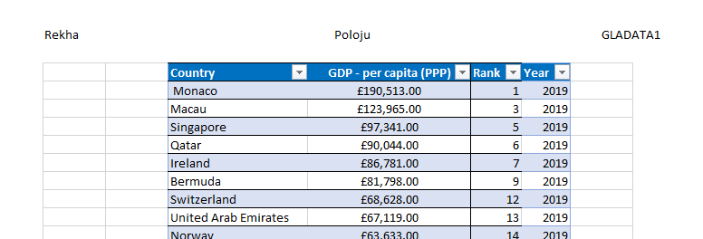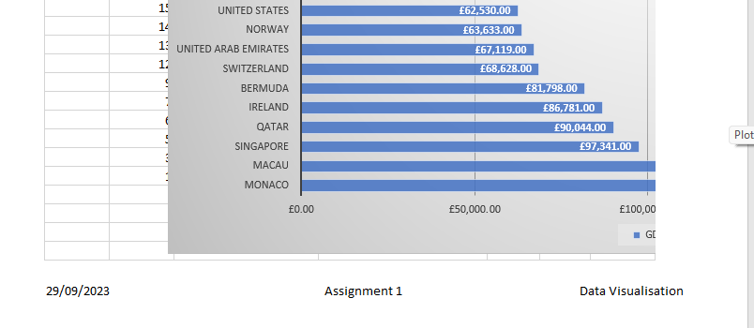



# 3. Part 4 (the PDF document)

## 3.1 Import data and set the relation

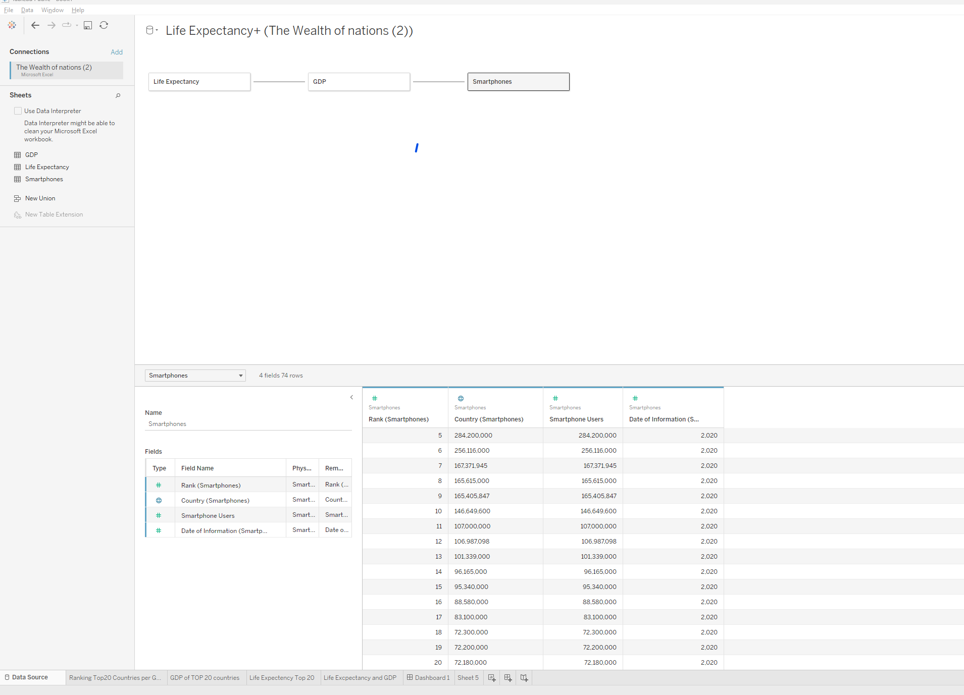

## 3.2 Create charts

* Click on new work sheet on the task bar at the bottom of the screen
* You should all excel sheet that are imported previously on the left hand side on the screen
* Drag and drop the values and legends in to rows and column fields on the screen, that you want to show in the chart
* You can also apply additional conditions via the Analytics tab. In the below chart I have added an average line
* 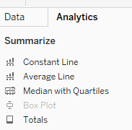
* Then created a Calculated field to apply additional condition to show the countries with above and below average GDP with the different colour coded legends
* 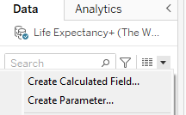

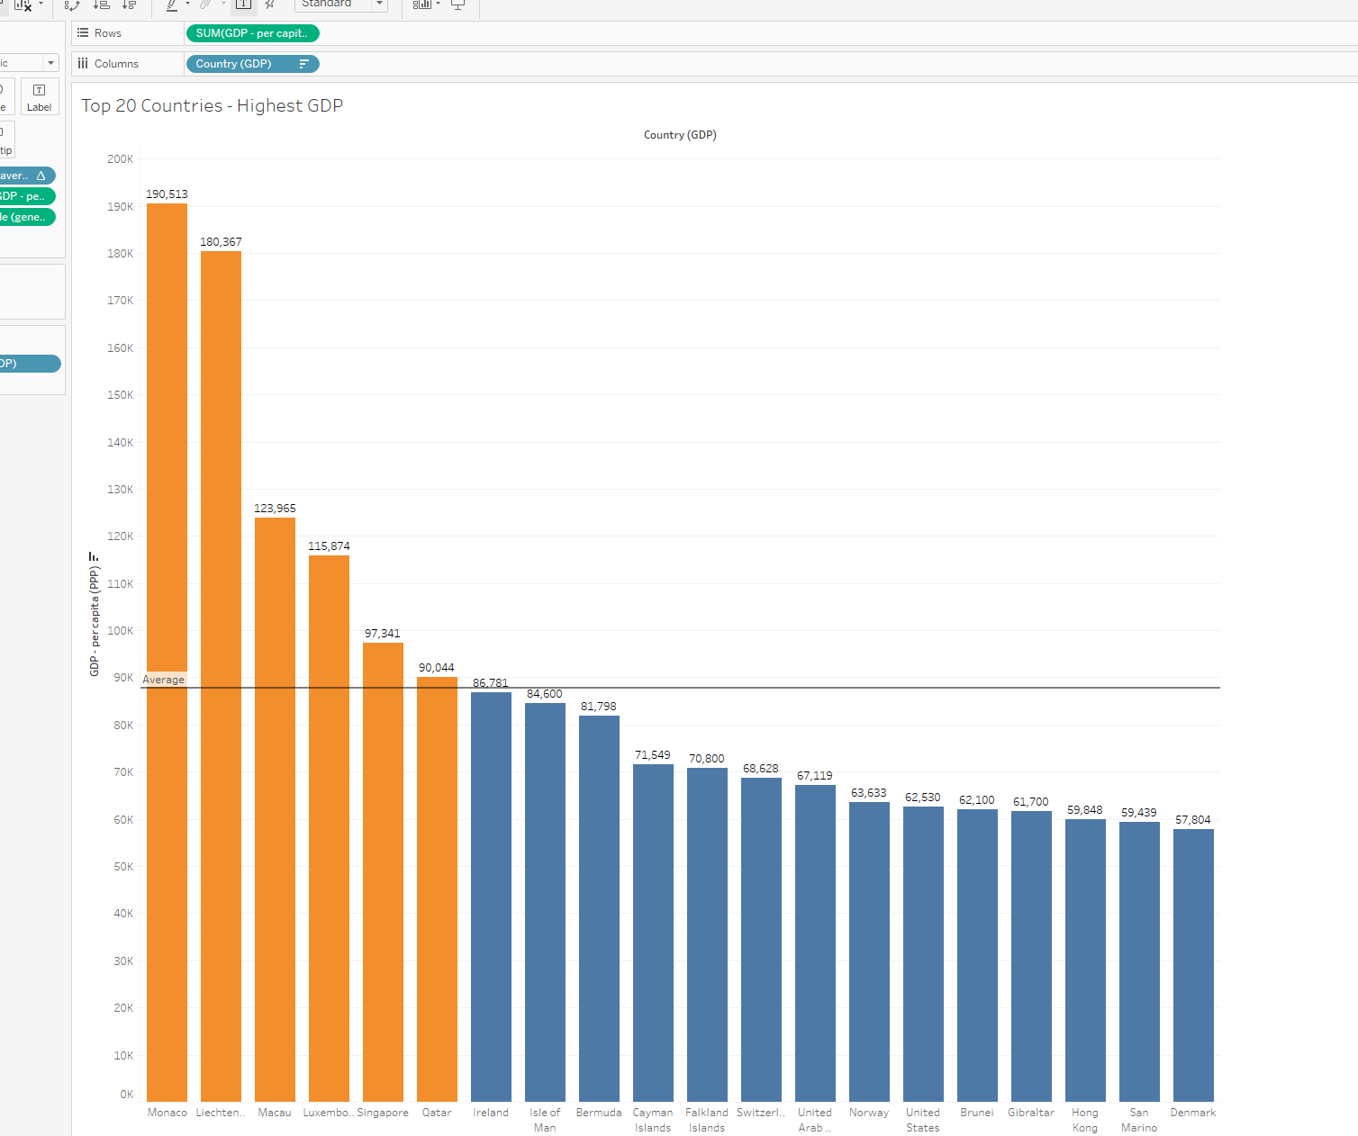

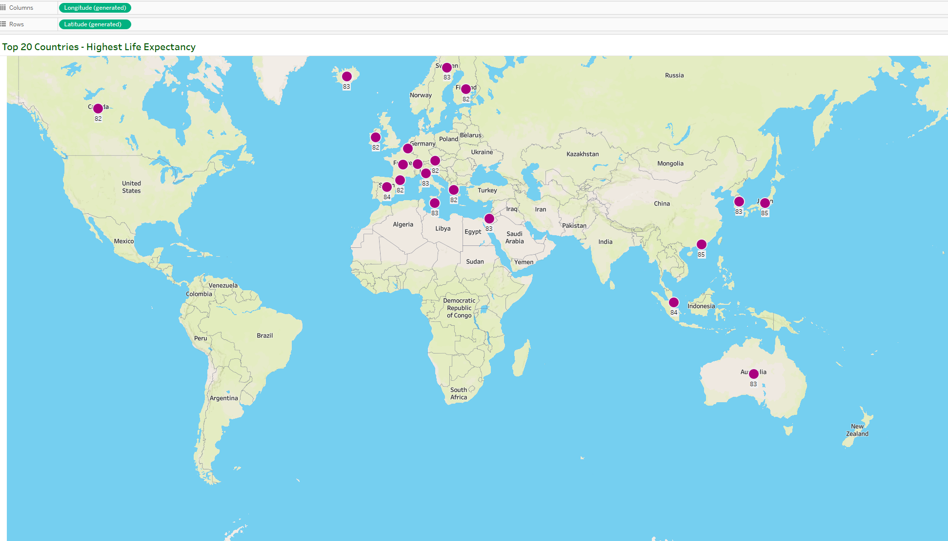

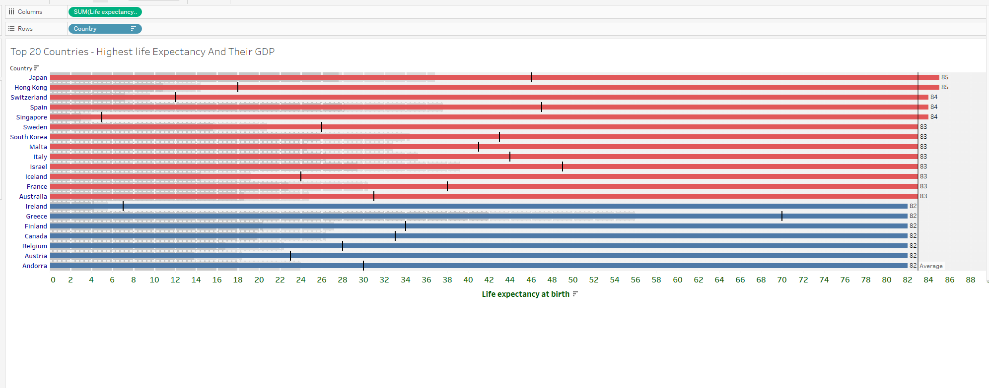

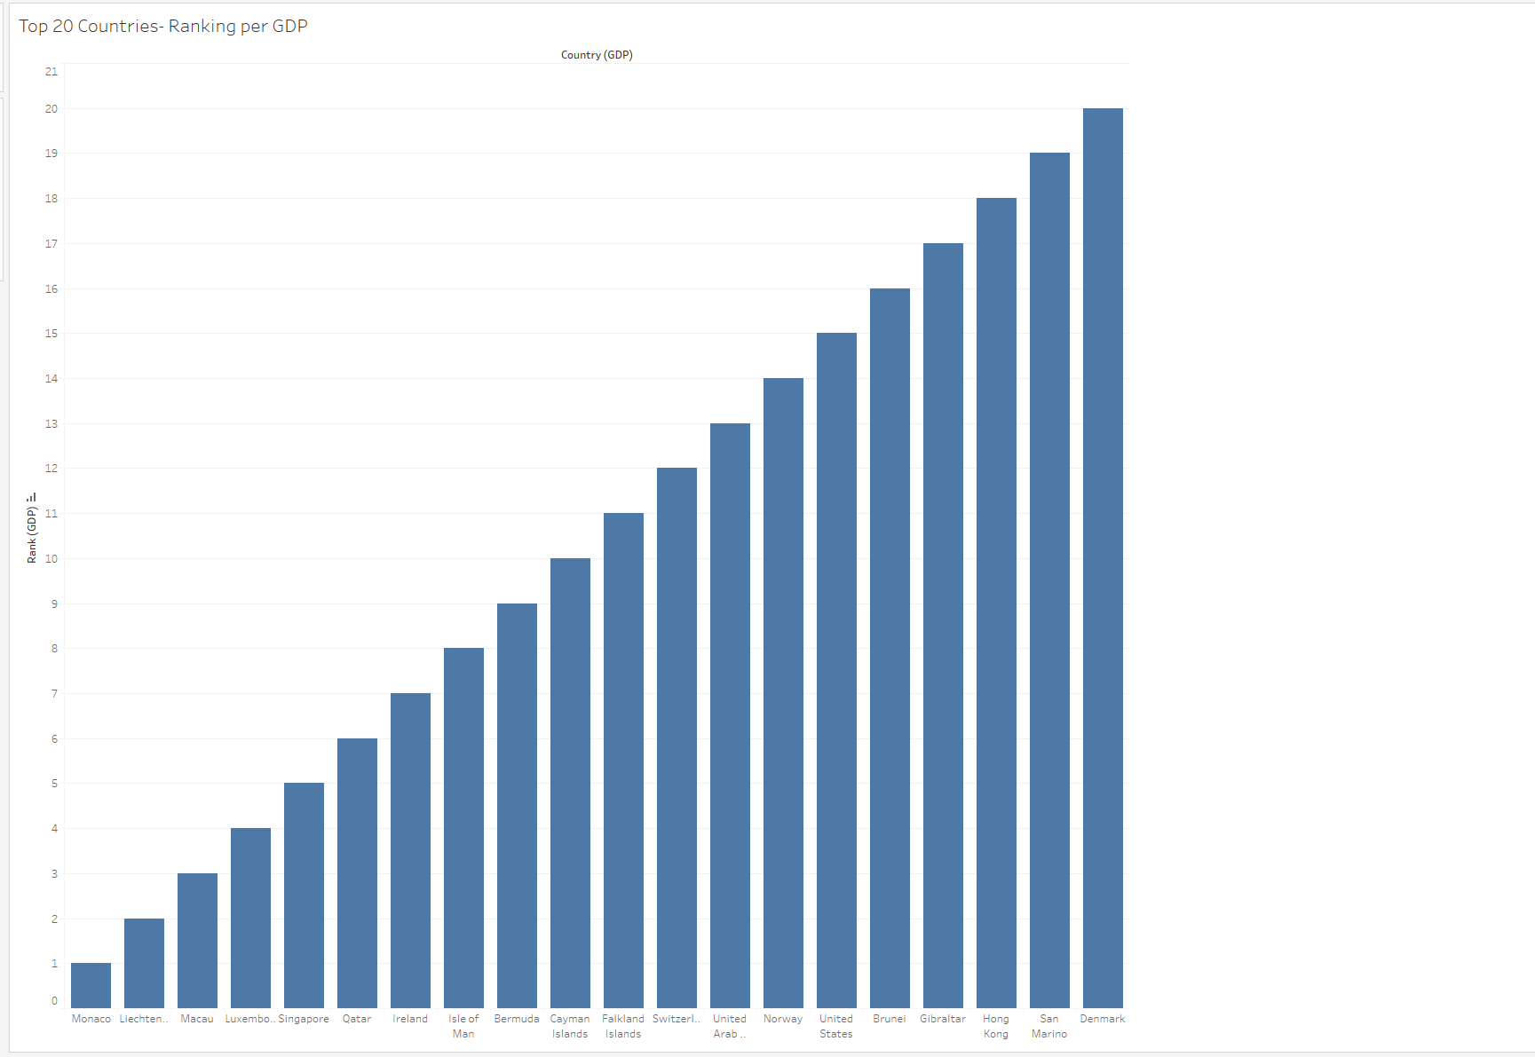

## 3.3 Dashboard

* Once you created individual charts click on the dashboard tab on the task bar at the bottom of the screen
* 
* Then click on Layout to define the size of your dashboard
* 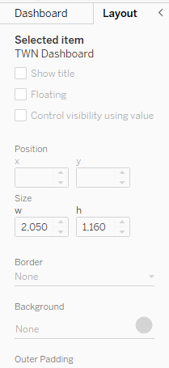
* Move onto the dashboard tab, press and hold SHIFT button then use the mouse to drag Vertical container and drop it in the dashboard plot area. Create multiple containers to host your individual charts.
* Then drop individual charts in to each container and align their position for better visual presentation

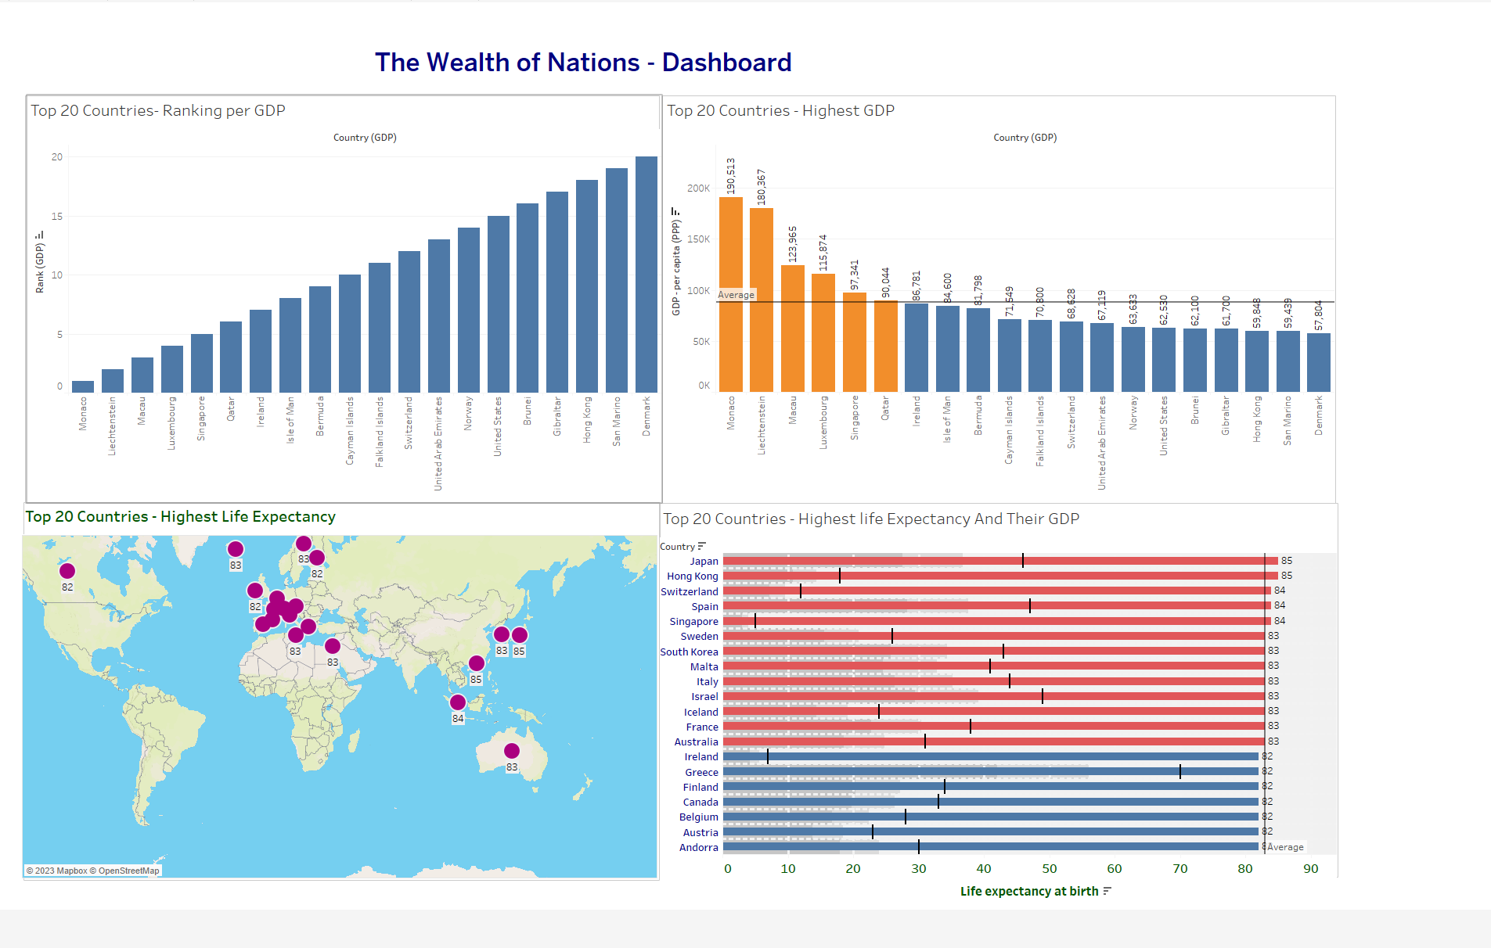

# 4. Reflective

## 4.1 What went well

This assignment was a good opportunity to put all learnings in the last weeks into practice independently. When I started off, I was a bit nervous, however, as I got through the first task, I started feeling more confident and enthusiastic to move on to the next.

I most enjoyed working on excel data formatting and creating different types of charts in excel and Tableau associated to this assignment.

## 4.2 Areas of Development

I had to seek extra support whilst working on creating Marcos, initially due to lack of understanding of excel extensions that support the enablement of Macro usage. Also, had difficulty with reference points and its significance whilst using a macro. I would want spend more time on learning Macro creations and management, as I found it very interesting once the basic Macro function worked.

## 4.3 Lessons learnt

* Type of excel extensions and their significance
* Macro can be ineffective if the reference point is not defined correctly